**Making Hospital Care Better for People with a Learning Disability**

NCEPOD is a charity.  We work to make healthcare better for everyone. We want to improve hospital care for people with a learning disability.  
  
**What is this study about?**  
We are collecting information to understand how hospitals can give better care to people with a learning disability.   
  
If you have been in hospital when you were unwell, we want to hear about your experience.   
  
The information we collect will help doctors, nurses, and other healthcare staff learn how to give better care.  
  
**Who can complete the questionnaire?**  
People with a learning disability who have stayed in a hospital overnight.  
**Want a copy of the report?**  
Email: **learning@ncepod.org.uk  
  
Your information is private**  
Your answers are confidential. We remove all personal details, so no one will know who you are.  
Privacy notice - <https://shorturl.at/Jucy4>    
 **How to return this survey to NCEPOD**  
📧 via Email: [**learning@ncepod.org.uk**](mailto:learning@ncepod.org.uk)

📧 via Post: RTBS-XCXG-RGLA, NCEPOD, Ground Floor, Abbey House, 74-76 St John Street, London, EC1M 4DZ (This is a free post address)

**Need help?**  
📞 Call: **0207 251 9060**

**Section A. Patient details**

1. **Do you have a learning disability?**

[ ] Yes

[ ] No – Please do not complete this survey

1. **Have you ever had to stay at overnight at hospital when you were unwell?**

[ ] Yes

[ ] No – Please do not complete this survey

[ ] Unsure

1. **What is your sex?**

[ ] Prefer not to say

[ ] Other – please give details

1. **How old are you?**

**Section B. Learning disability awareness**

**1. Did the hospital staff know that you had a learning disability when you got to hospital?**

[ ] Yes - Go to question 2

[ ] No – Go to Section C – Hospital passport

[ ] Unsure/ Can’t remember – Go to Section C – Hospital passport

**2. If Yes, How did the hospital staff know that you had a learning disability?**

*Please tick all that apply*

[ ] The hospital team know you already or could see it on your

notes/ records

[ ] From your hospital passport

[ ] You told them

[ ] Your family/ friend or carer told them

[ ] They asked you/ your carer if you have a learning disability

[ ] Unsure/ Can’t remember

[ ] Other – please give details

**Section C. Hospital passport**

This is a form used to help hospital staff know more about your needs, and how to care and support you.

1. **Do you have a hospital passport?**

[ ] Yes – Go to question 2

[ ] No – Go to section D

[ ] Unsure/ Can’t remember – Go to section D

1. **If Yes, Did someone ask to look at your hospital passport?**

[ ] Yes - Go to question 3

[ ] No – Go to section D

[ ] Unsure/ Can’t remember – Go to section D

1. **If Yes, Was your hospital passport used?**

[ ] Yes

[ ] Maybe

[ ] No

[ ] Unsure/ Can’t remember

**Section D. Carers helping you whilst in hospital**

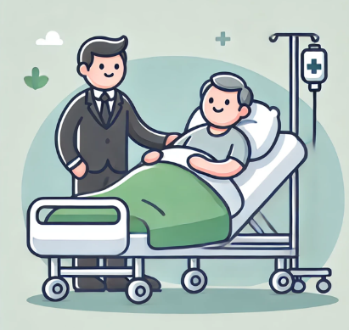

1. **Was a family/ friend or carer able to be with you as much as you needed when you stayed in hospital?**

[ ] Yes - Go to question 2

[ ] No – Go to question 5

[ ] Unsure/ Can’t remember – Go to question 5

1. **If Yes, Was it helpful having them there?**

[ ] Yes – Go to question 3

[ ] No – Go to question 4

[ ] Unsure/ Can’t remember – Go to question 5

1. **If Yes, what did they do that was helpful?**

*Please tick all that apply, then go to question 5*

[ ] Sharing information about your health

[ ] Helping you make decisions about your health, such as having blood test

[ ] Helping you eat and drink

[ ] Helping you wash and get dressed

[ ] Unsure/ Can’t remember

[ ] Other – please give details

1. **If No, Why was it not helpful?**

[ ] I don’t need anyone to help me

[ ] People not available to help me

[ ] Unsure/ Can’t remember

[ ] Other – please give details

1. **Did the hospital learning disability team come to see you/ talk to your carers when you were in hospital?**

[ ] Yes – Go to question 6

[ ] No - Go to question 8

[ ] Unsure/ Can’t remember - Go to question 8

1. **If Yes, Do you think this was helpful?**

[ ] Yes – Go to question 7

[ ] No - Go to question 8

[ ] Unsure/ Can’t remember - Go to question 8

1. **If Yes, Why was this helpful?**
2. **Did the hospital staff keep you up to date with your care whilst you were in hospital?**

[ ] Yes

[ ] No

[ ] Unsure/ Can’t remember

**Section E. Reasonable adjustments**

These are changes that can be made to support someone with a learning disability. These could include changes such as easy read information or allowing your carer to stay with you after visiting hours.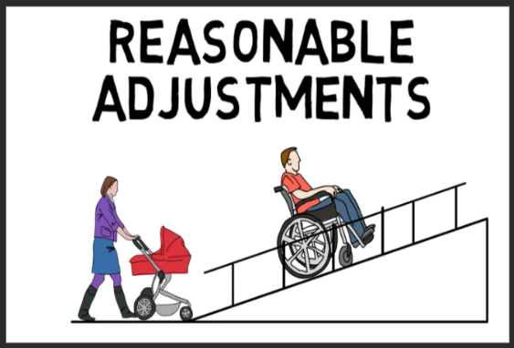

**1. During your time in hospital, were any changes offered/ made to meet your needs?**

[ ] Yes

[ ] No – Go to question 5

[ ] No – not needed – Go to question 5

[ ] Unsure/ Can’t remember – Go to question 5

**2. If Yes, What changes were made?**

*Please tick all that apply*

[ ] **Time –** Such as longer time with the nurse or doctor

[ ] **Environment –** Such as quieter room or ear defenders

[ ] **Attitude –** Such as your carer being able to stay outside visiting hours

[ ] **Communication –** Such as easy read leaflets; Talking Books/ Mats; British Sign Language; Makaton etc

[ ] **Help –** Such as including the learning disability team

[ ] Other – please give details

**3. If Yes, Were there any changes made that really helped you?**

[ ] Yes

[ ] No

[ ] Unsure/ Can’t remember

1. **Please tell us more about what helped you whilst you were in hospital:**
2. **Is there anything else that could have helped you when you were in hospital?**

**Section F. Leaving hospital**

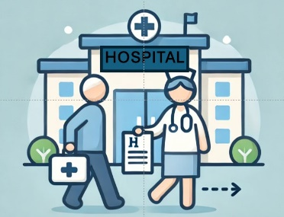

**1. Did you feel you were involved in making decisions about your health?**

[ ] Yes

[ ] Sometimes

[ ] No

[ ] Unsure/ Can’t remember

[ ] Prefer not to say

**2. When you left hospital, did you know whether anything was planned next for your future care?**

[ ] Yes

[ ] No

[ ] Unsure/ Can’t remember

**Section G. Overall comments**



1. **Do you have any suggestions on how to improve care for people with a learning disability when they are in hospital?**
2. **So we can share good ideas, please tell us what REALLY WORKS WELL when someone with a learning disability stays in hospital:**

Do you have any suggestions for how we can make this survey better?